Johnny Louis

Computing as a Service - RDS and Manipulating Data

**\*\*instance has stopped: johnnylouisdatabase-1.csgvee2hi172.us-east-2.rds.amazonaws.com**

**RDS/MySQL instance:**

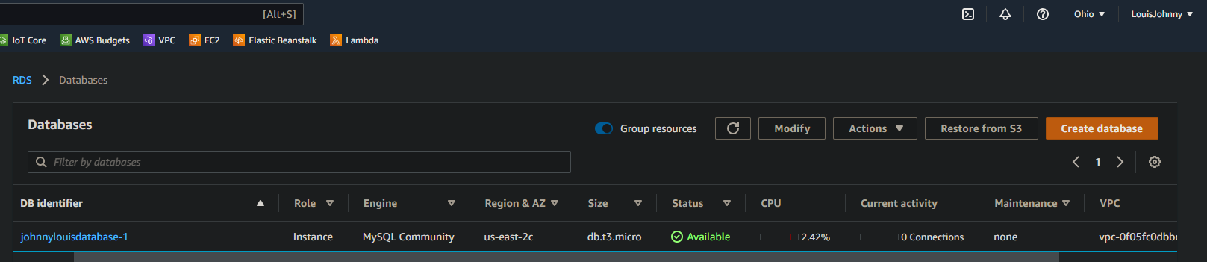

**MySQ**L: Connect your database to MySQL Workbench

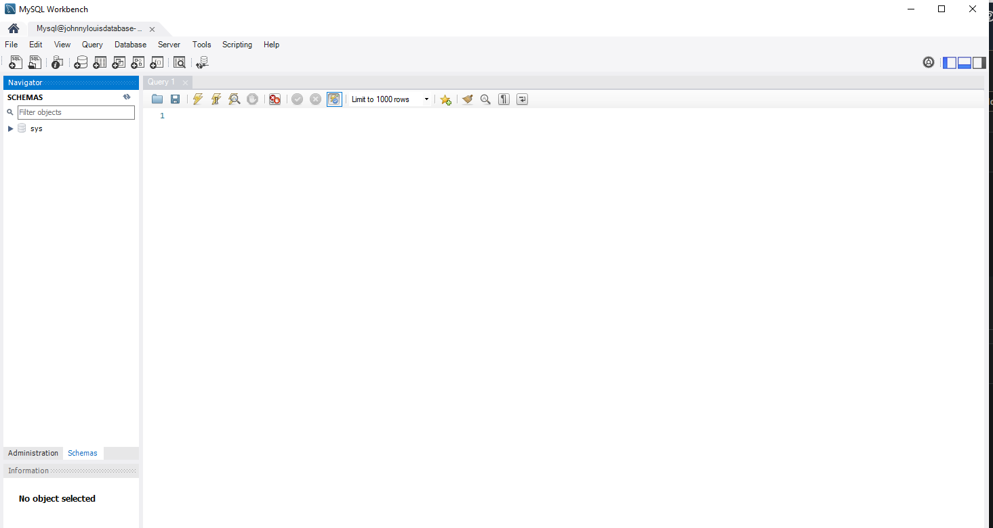

**Database Schema:**

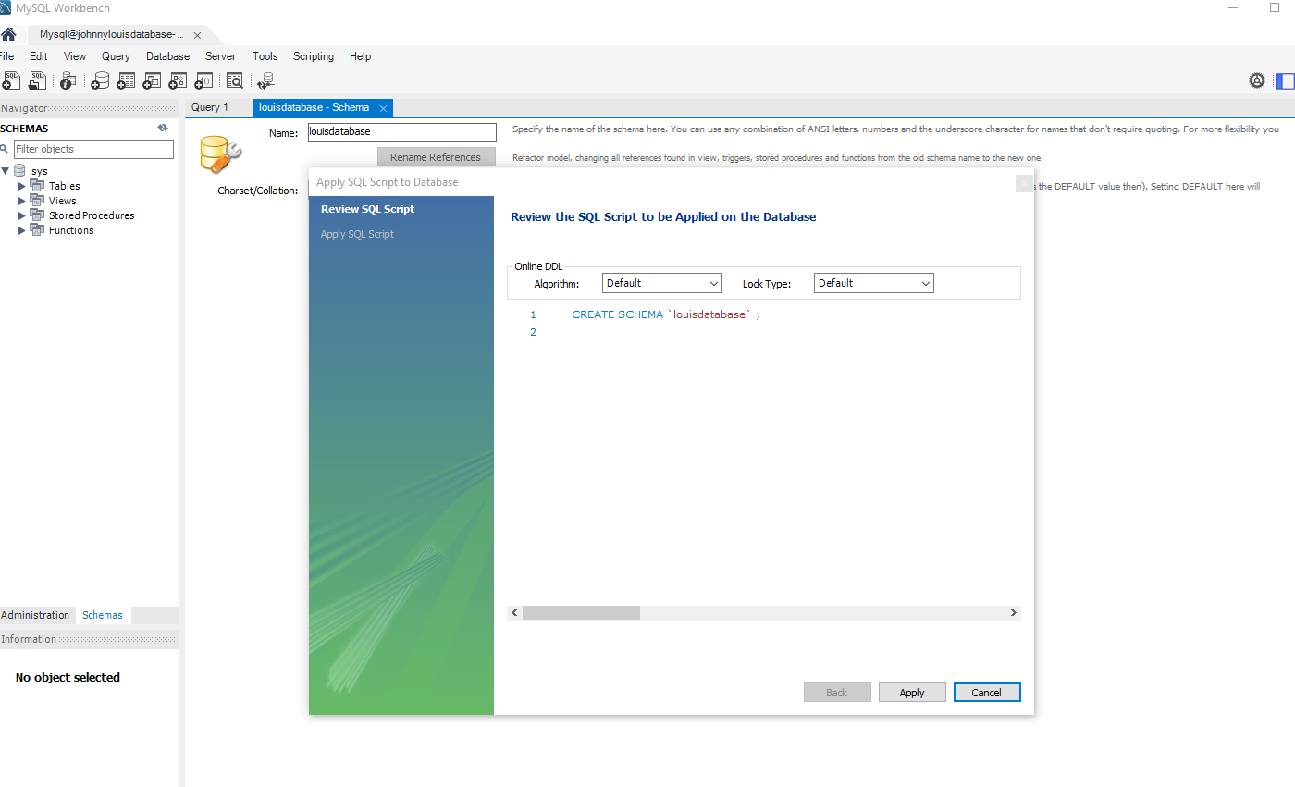

**Tables:** Create tables for Employees, Manager/Employee, Managers, and Customers

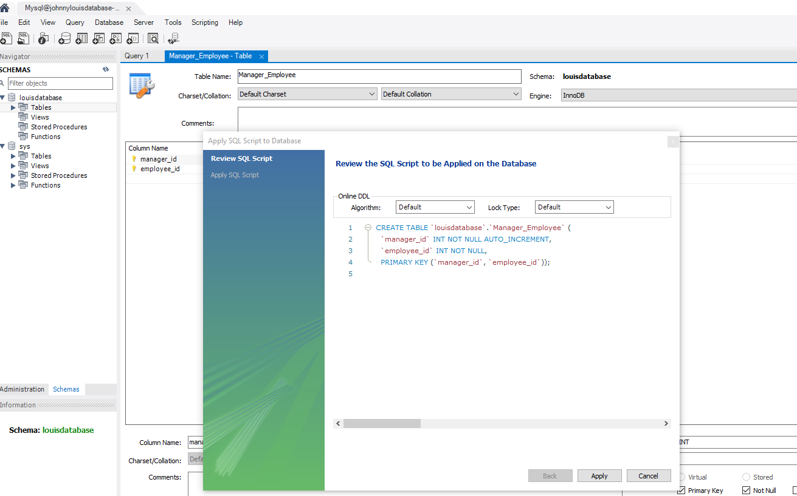

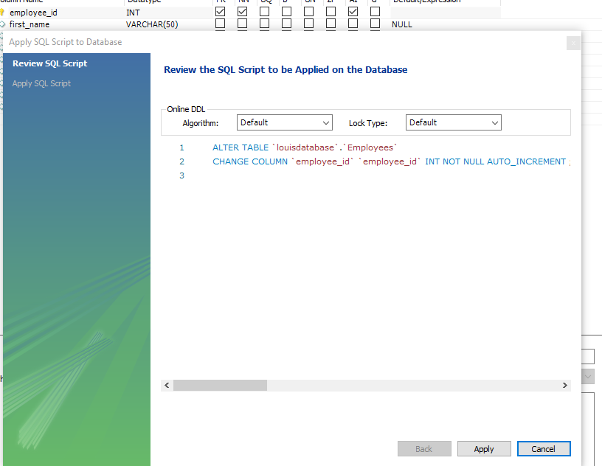

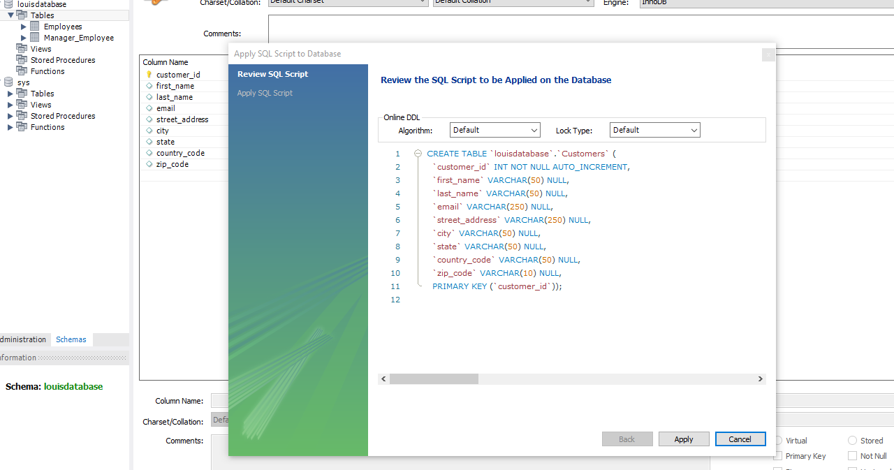

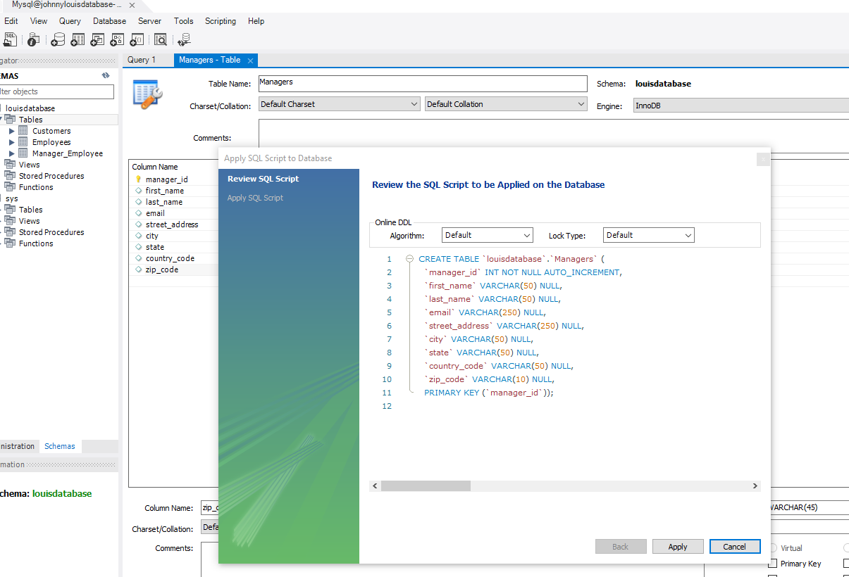

**Show tables command:**

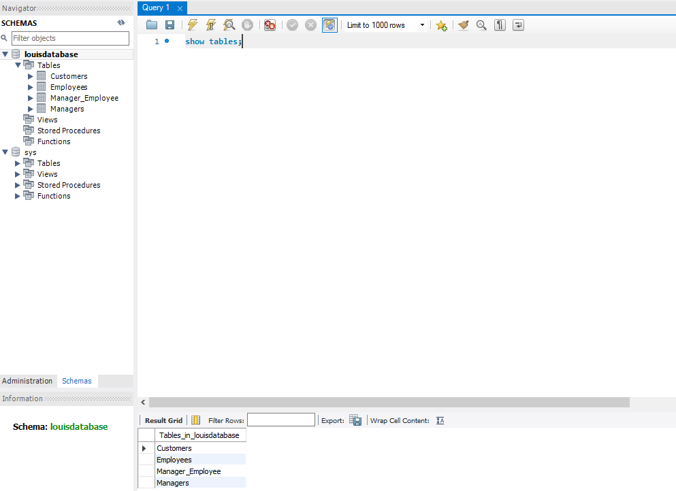

**Keys and Attributes**: Include the appropriate attributes in the tables

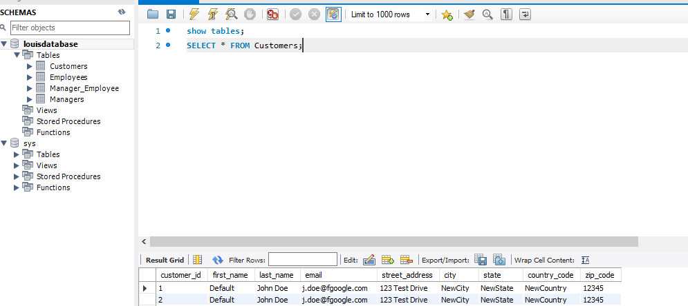

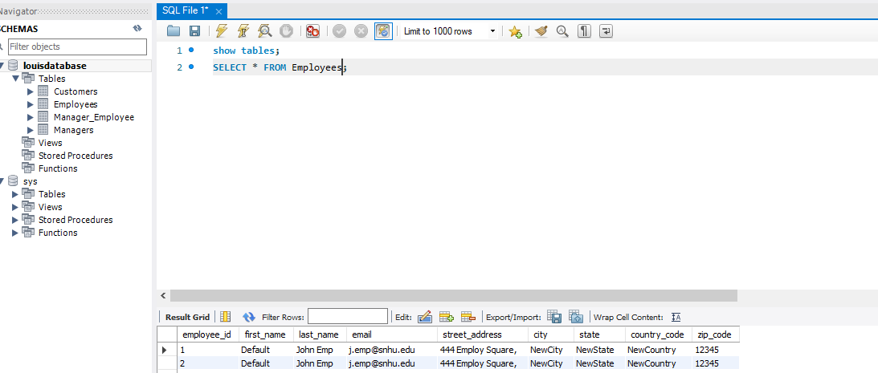

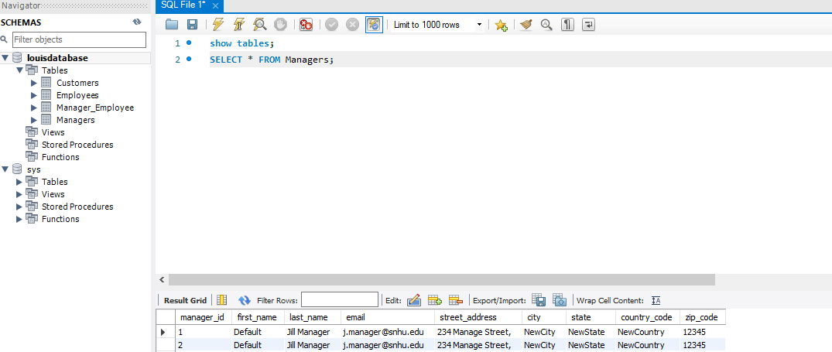

**Data Manipulation**: Assign employees Jill Employ and John Emp to their manager, Jill Manager

